Moreno, Melissa

April 13, 2019

SUR 5386

Tutorial 7- Supervised Classification of Hyperspectral Imagery

**Step 1: Minimum Noise Fraction Transformation**

b. Open ENVI software: START >> All Programs >> ENVI 5.x >>64-bit>> ENVI 5.x (64-bit)

c. Open f100831t01p00r10rdn_FLAASH_GeoRectified in ENVI.

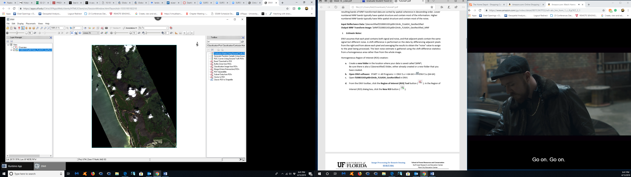

d. From the ENVI toolbar, click the Region of Interest (ROI) Tool button ( ). In the Region of Interest (ROI) dialog box, click the New ROI button ( ).

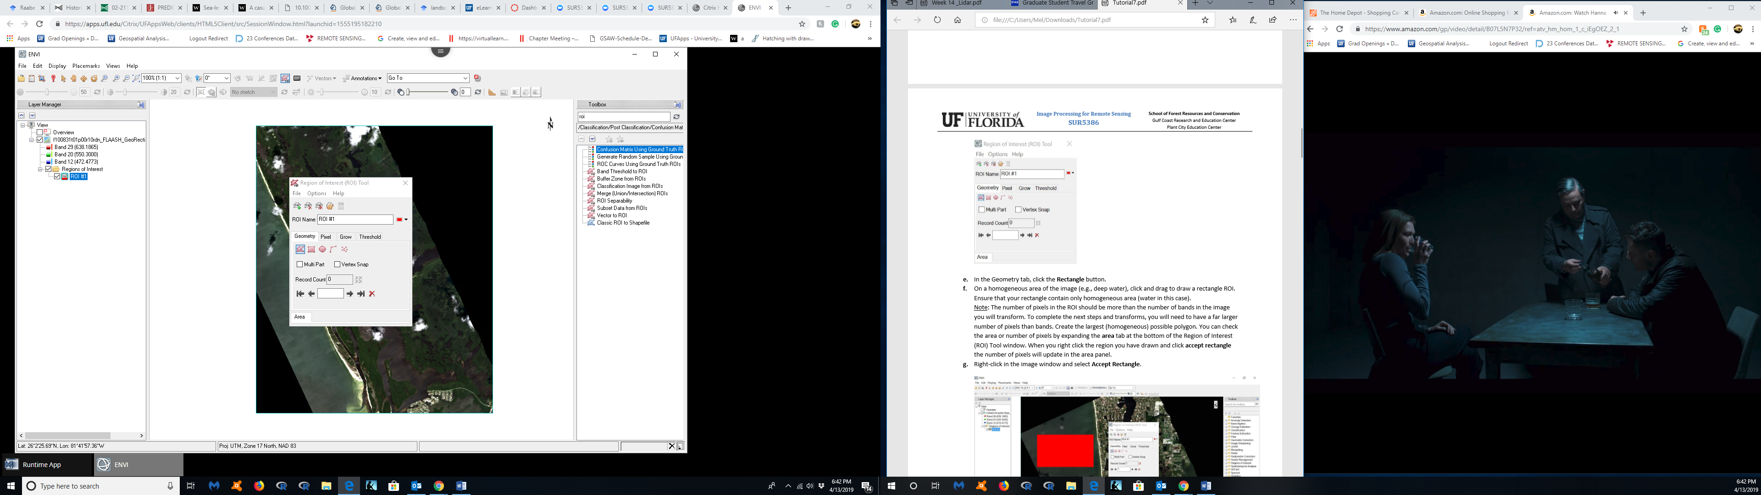

e.f.g

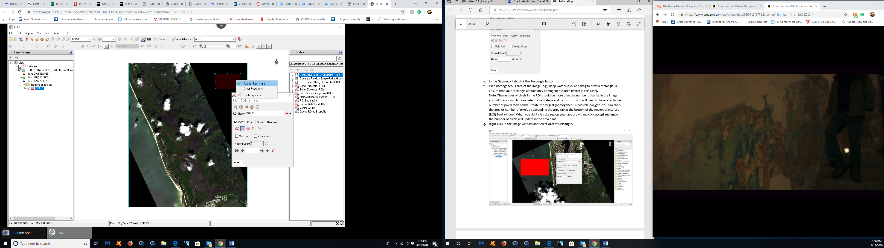



h.

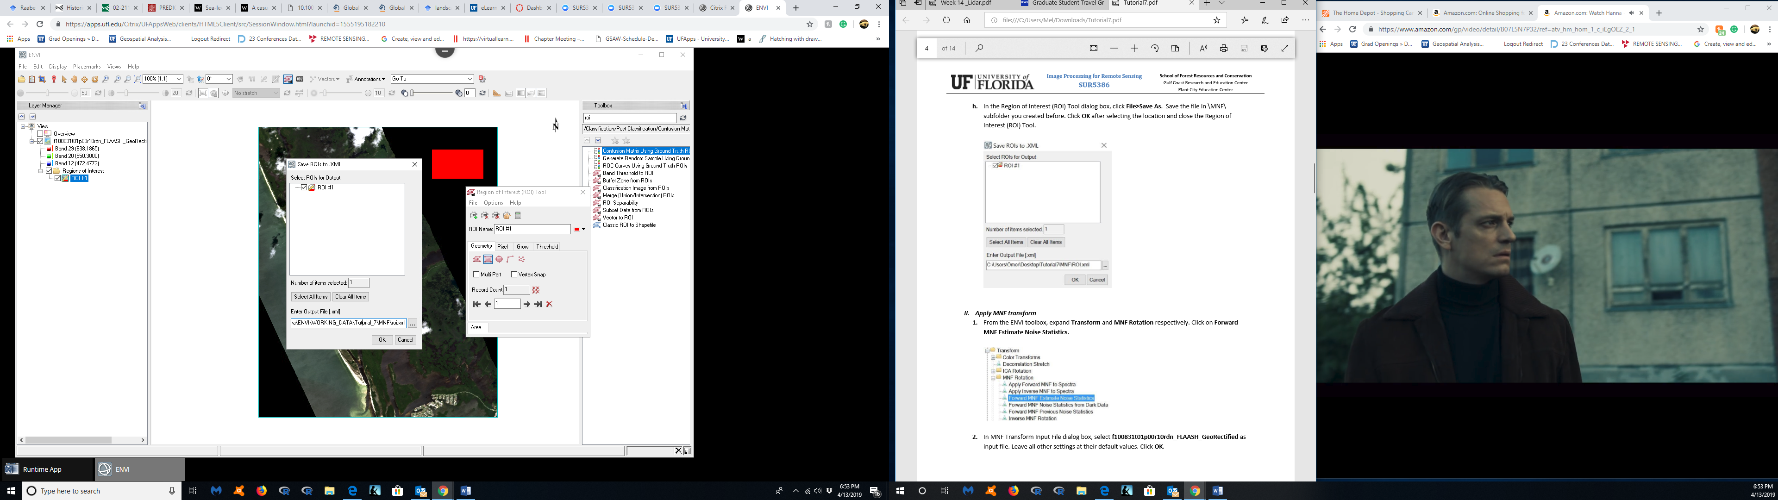

**II. Apply MNF transform**

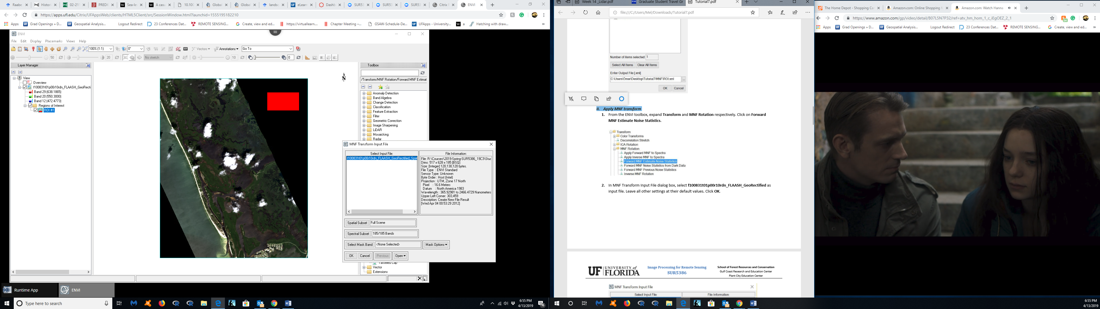

2.

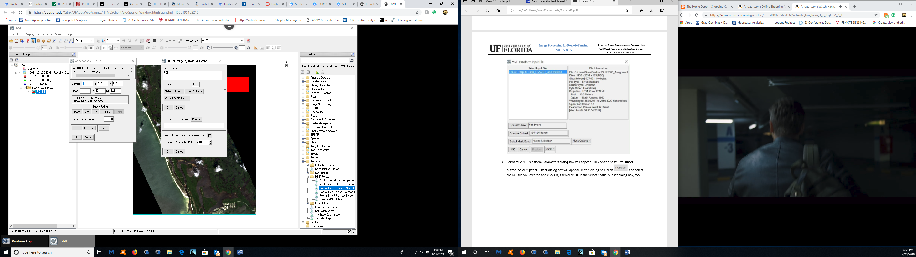

6. (Did the steps for a new area that had more pixels so I wouldn’t get the error, so the color is now green, but the steps are the same as the instructions and as above)

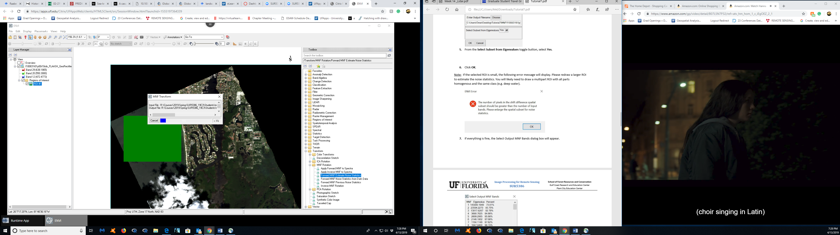

7. Selected the first 20 bands.

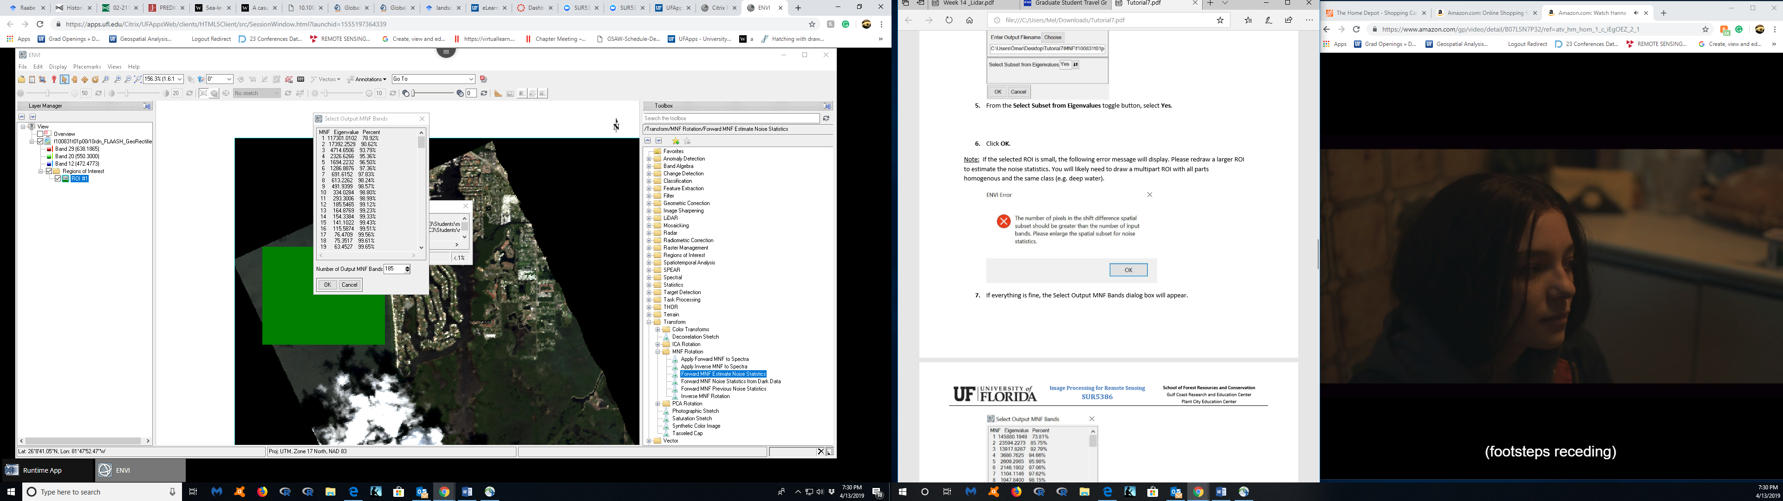

8.

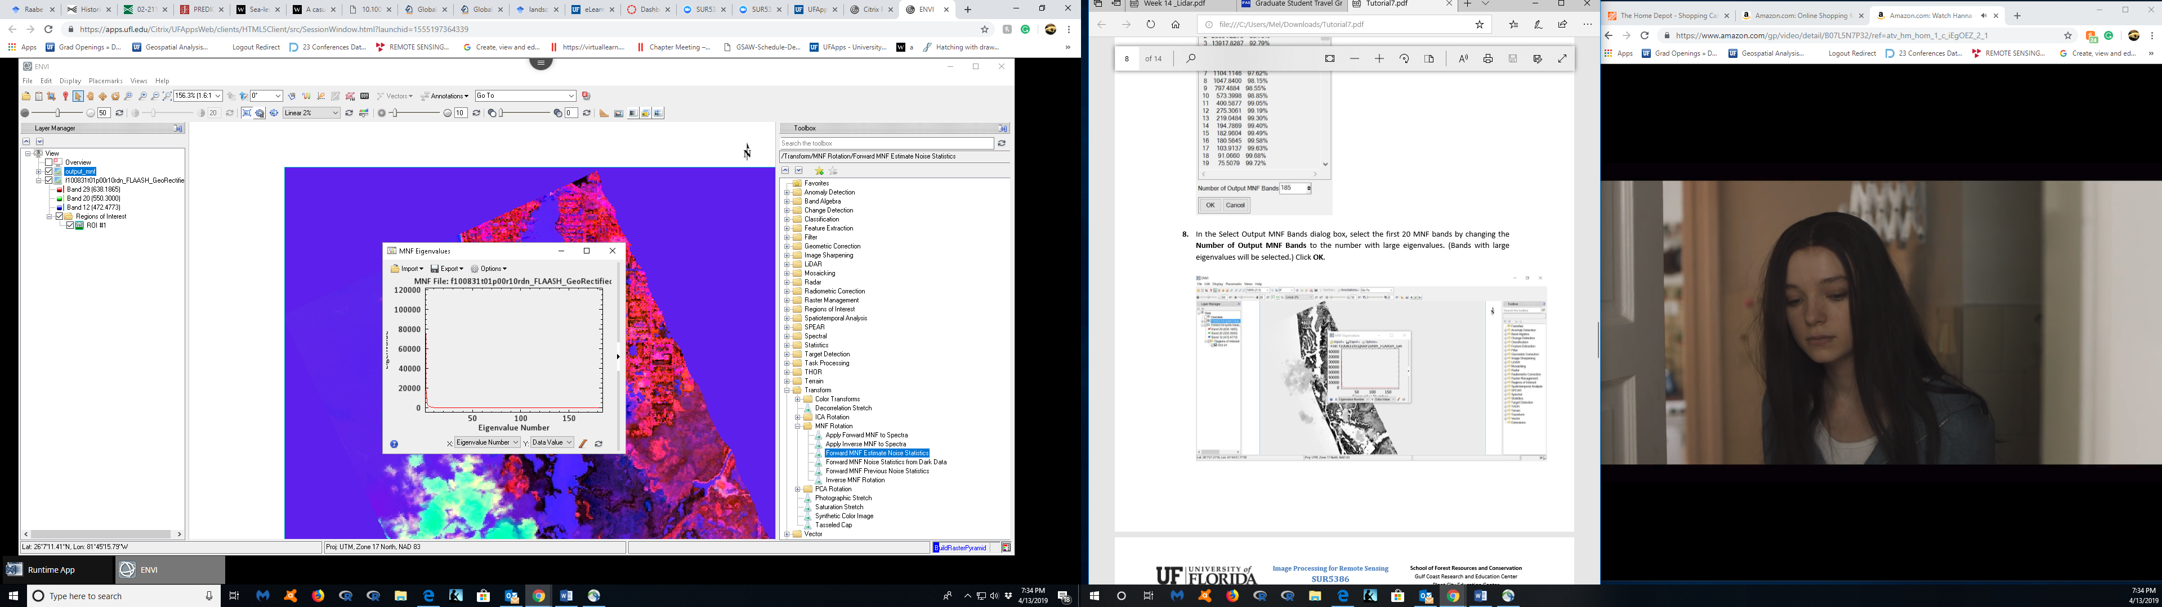

**Step 2: Spatial Subset**

4.

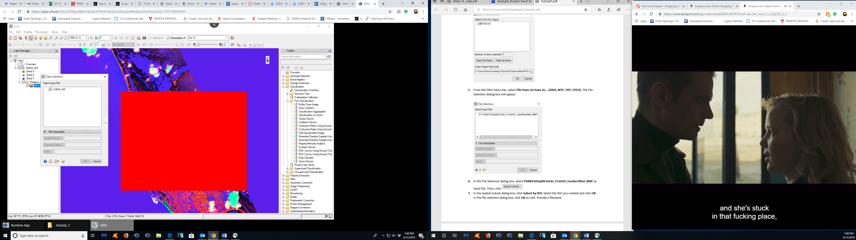

7.

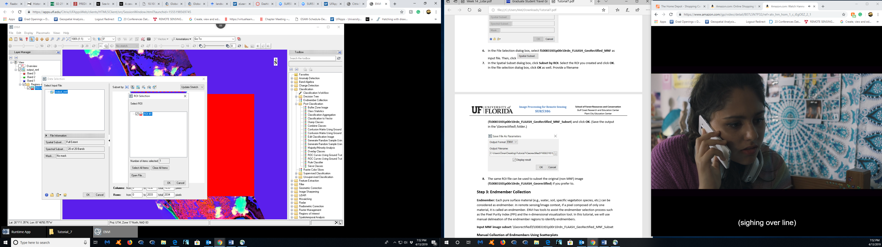

8.

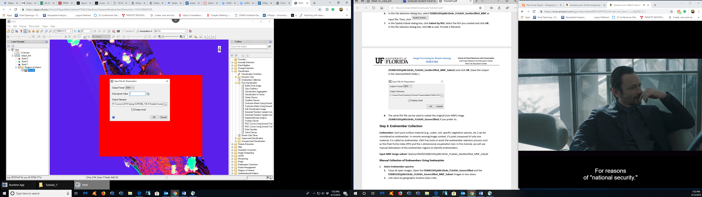

**Step 3: Endmember Collection**

2.

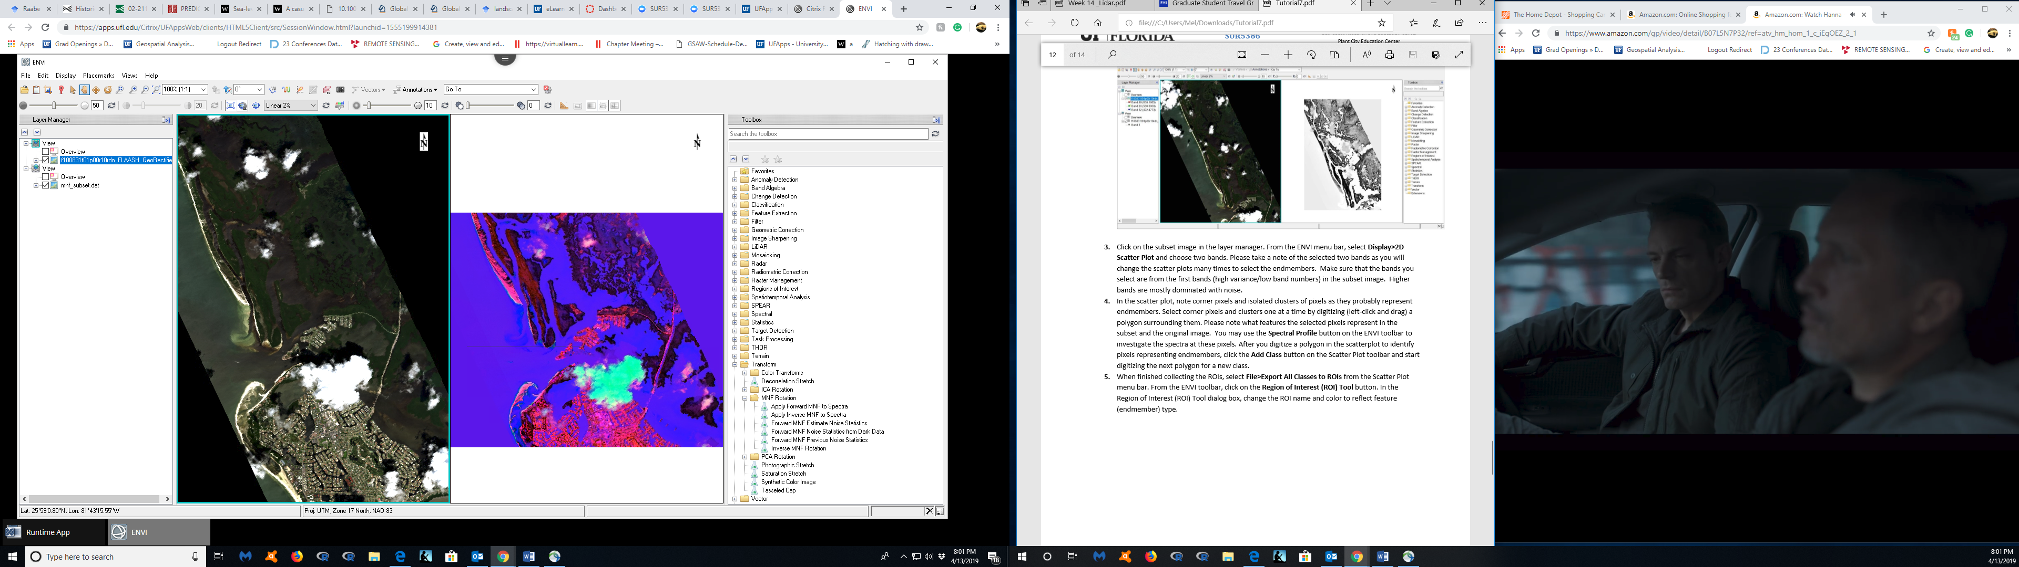

4.

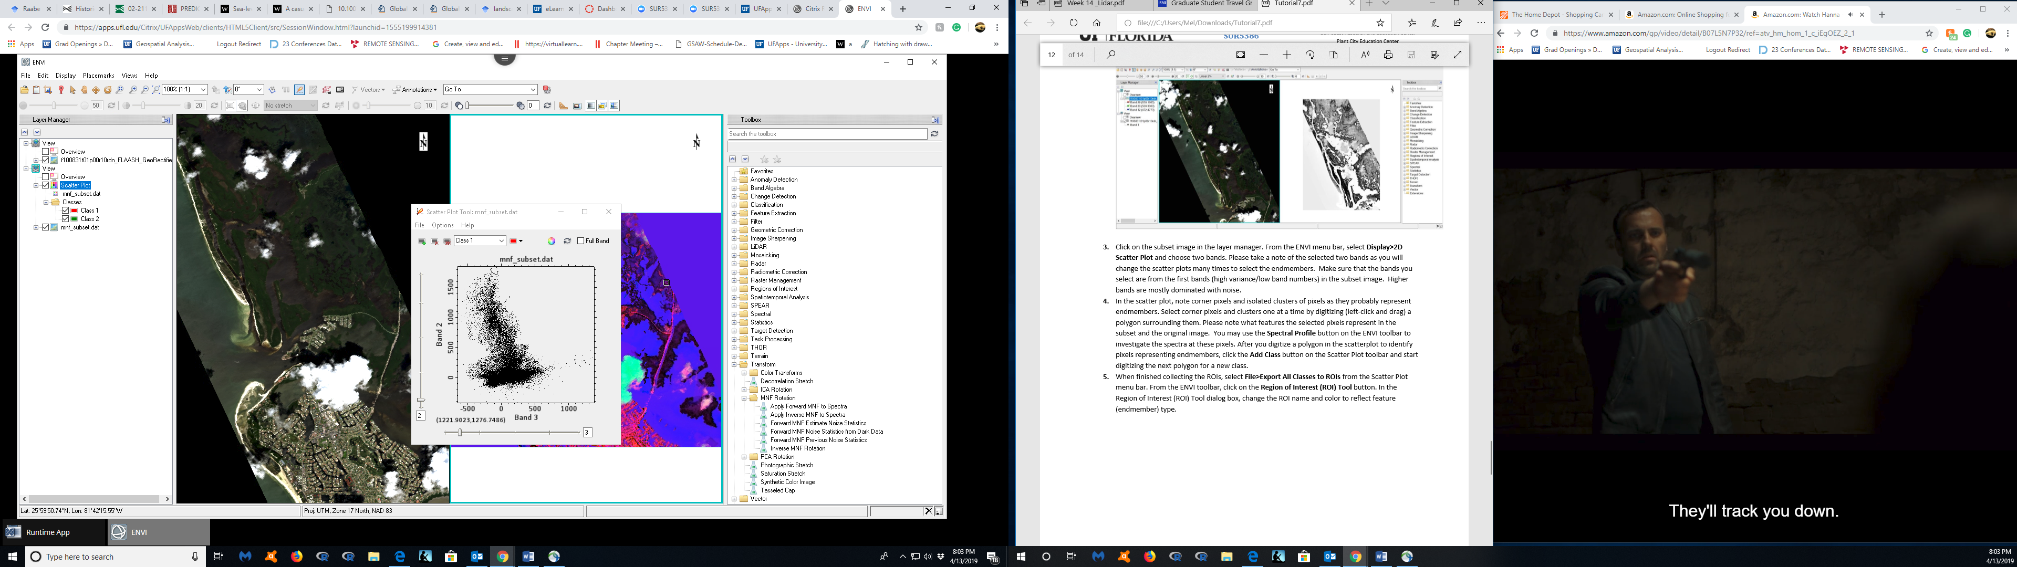

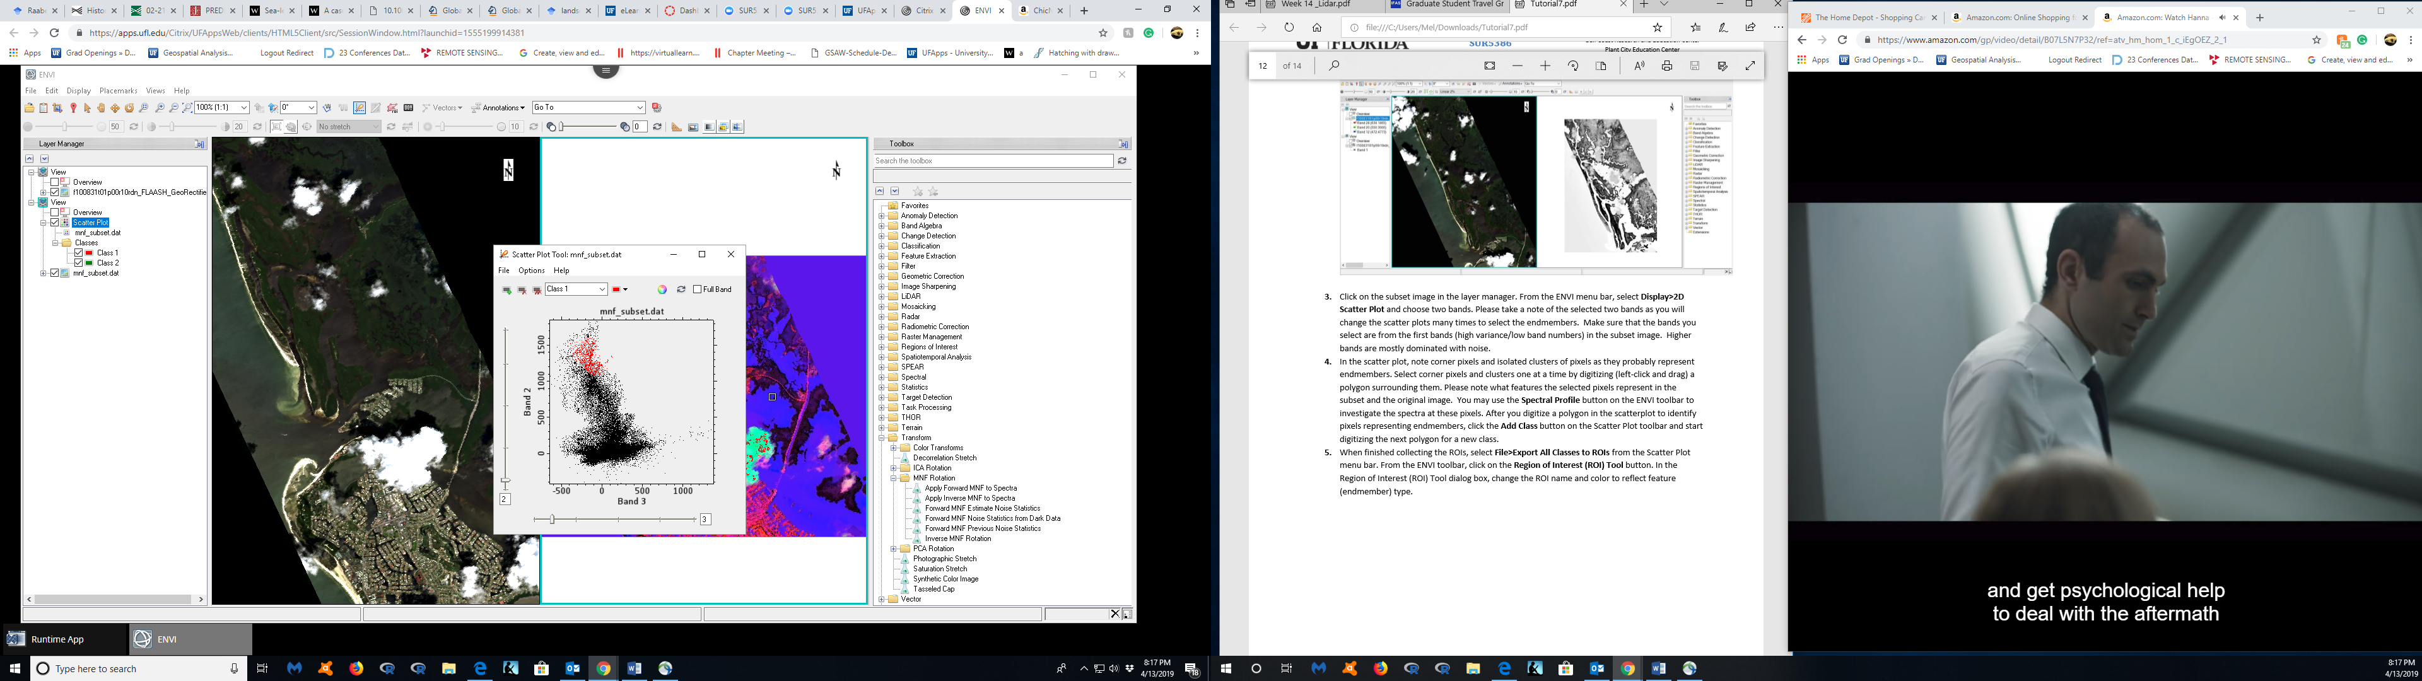

6.

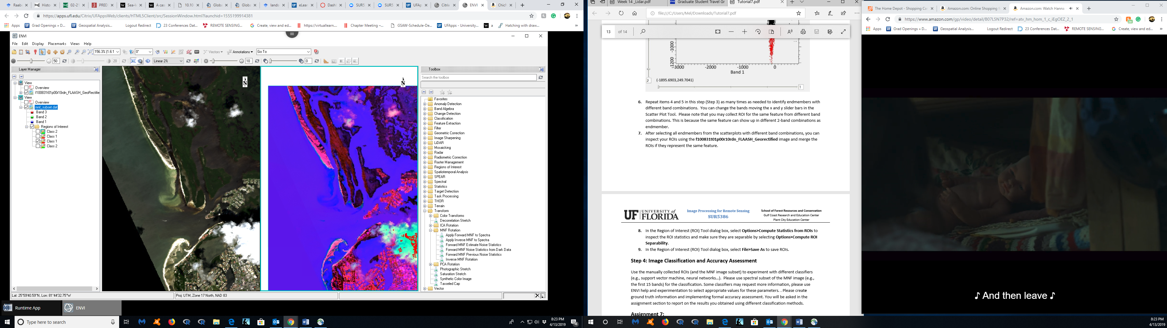

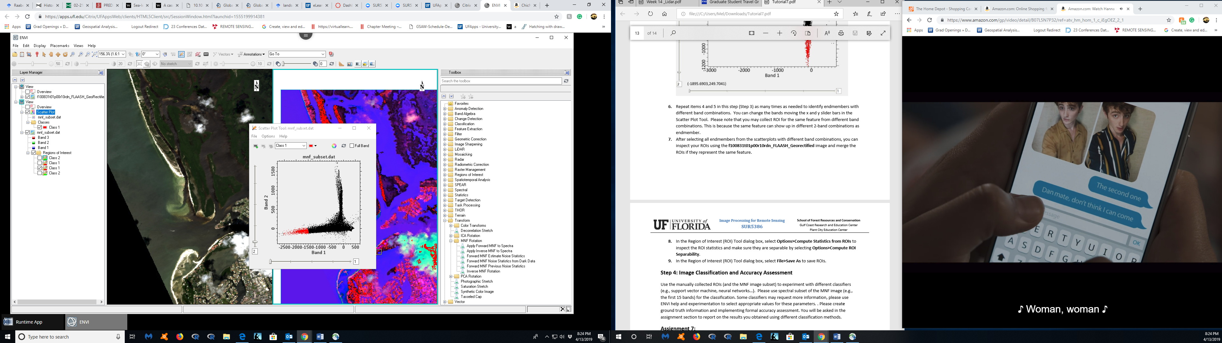

8.

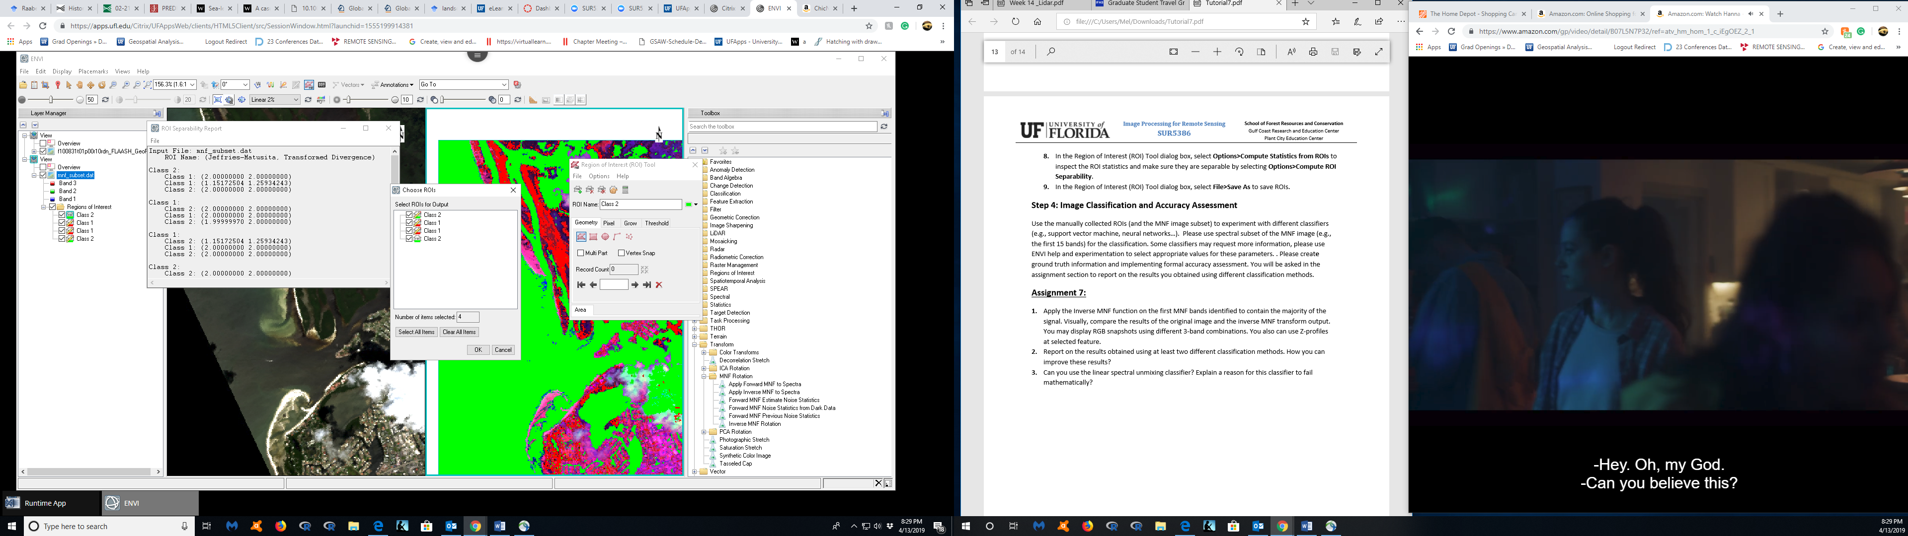

**Step 4: Image Classification and Accuracy Assessment**

No manually collected ROIs, but if this were a real assessment, we would definitely need ground truthing. The ground truthing would show up is the spectral bands that we are identifying are correct and accurate.

If I was ground truthing I would be looking for specific parameters.

(<http://priede.bf.lu.lv/GIS/.Descriptions/RST/Sect13/nicktutor_13-1.shtml>)

* Correlate surface features and localities as known from familiar ground perspectives with their expression in satellite imagery
* Provide input and control during the first stages of planning for analysis, interpretation, and application of remote sensing data (landmark identification, logistics of access. etc.)
* Reduce data and sampling requirements (e.g., areas of needed coverage) for exploration, monitoring, and inventory activities
* Identify classes established by unsupervised classification
* Select and categorize training sites for supervised classification
* Verify accuracy of classification (error types and rates) by using quantitative statistical techniques
* Obtain quantitative estimates relevant to class distributions (e.g. field size; forest acreage)
* Collect physical samples for laboratory analysis of phenomena detected from remote sensing data (e.g., water quality; rock types; insect-induced disease)
* Acquire supplementary (ancillary) non-remote sensing data for interpretive model analysis or for integration into Geographic Information Systems
* Develop standard sets of spectral signatures by using ground-based instruments
* Measure spectral and other physical properties needed to stipulate characteristics and parameters pertinent to designing new sensor systems

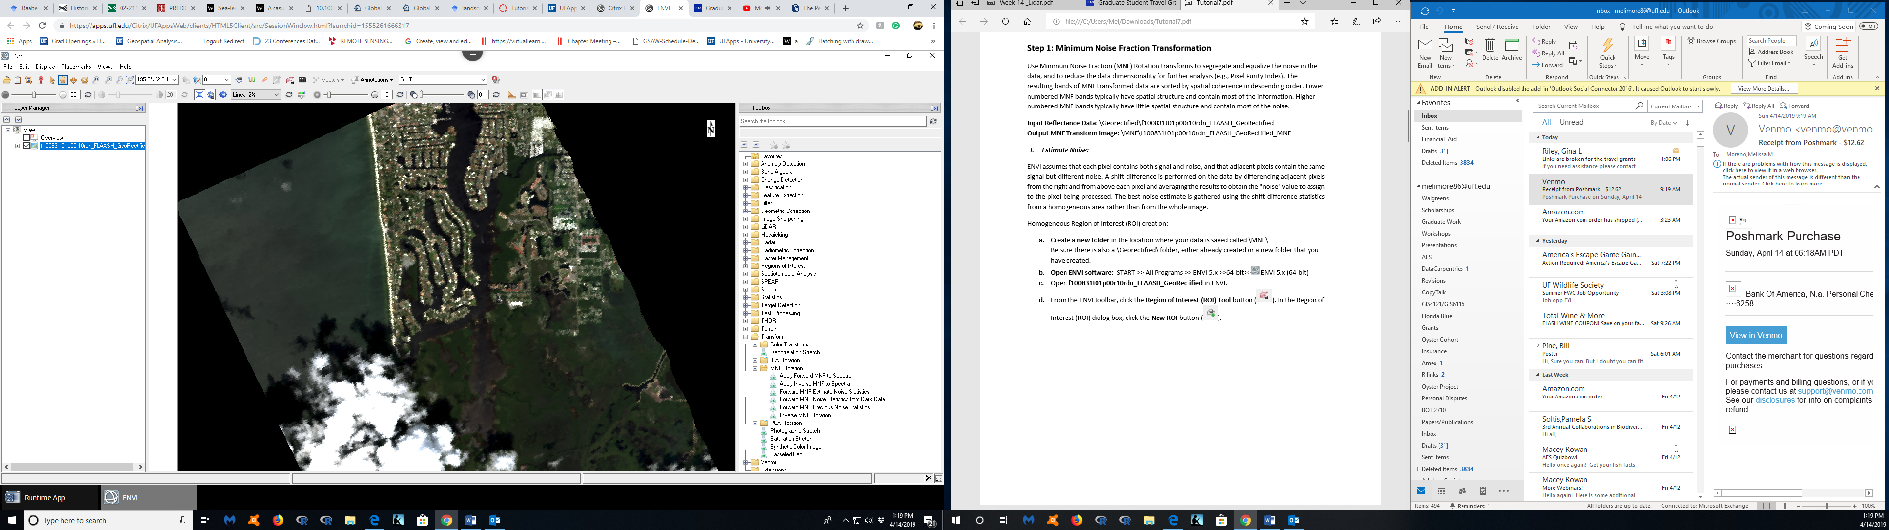

**Assignment 7:**

1. Apply the Inverse MNF function on the first MNF bands identified to contain the majority of the signal. Visually, compare the results of the original image and the inverse MNF transform output. You may display RGB snapshots using different 3-band combinations. You also can use Z-profiles at selected feature.

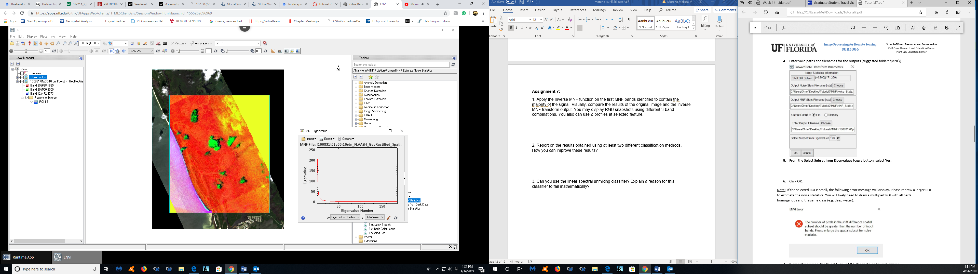

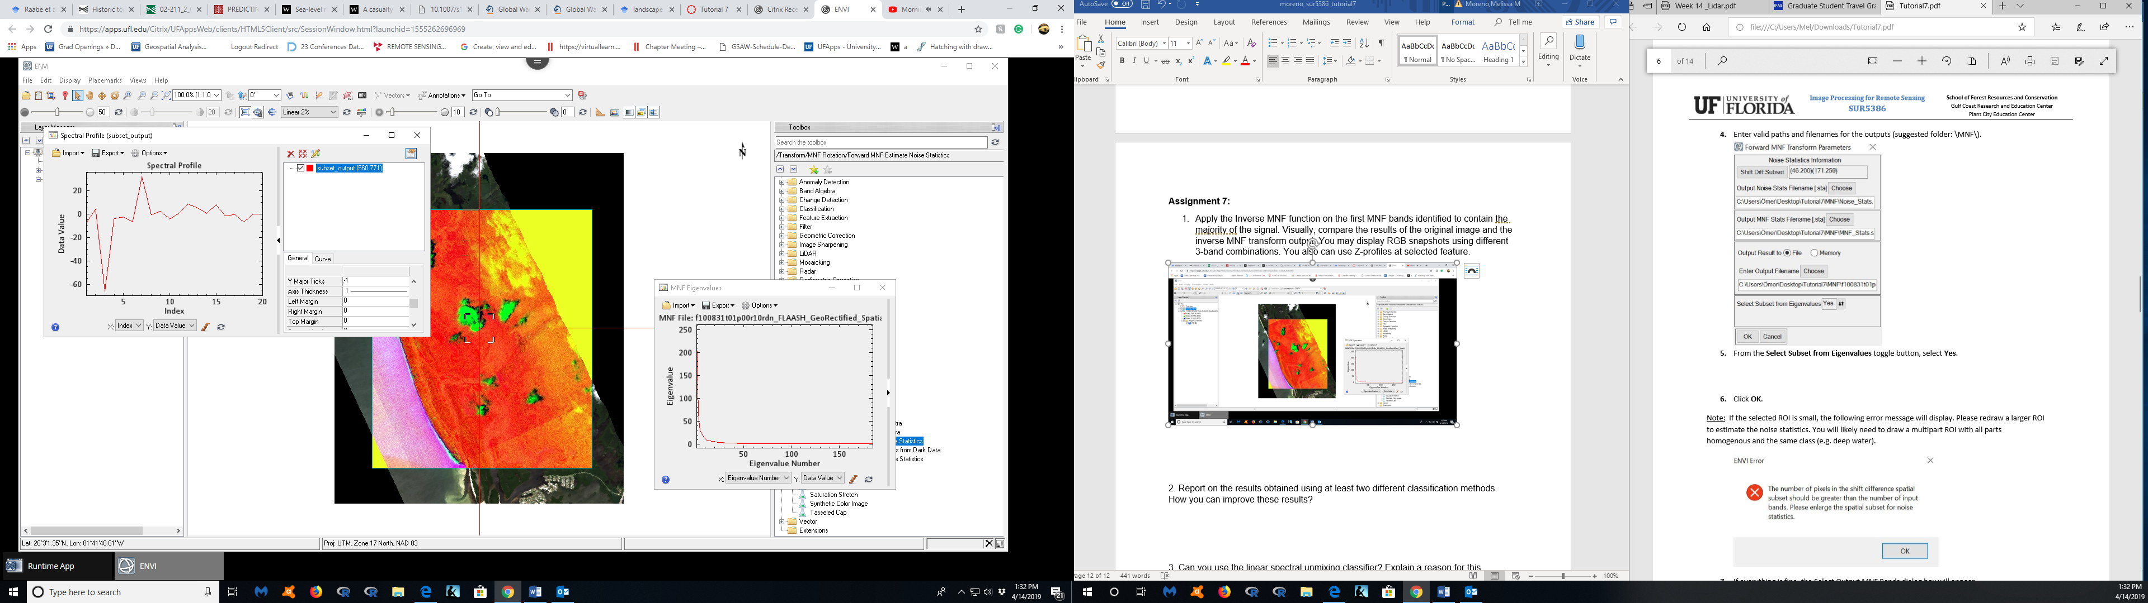

Using the MNF transform output, the bands that look like they have the highest value are the bands from 6-8. These bands have high data value. The lowest band is band 2 according to this spectral profile of this subset.

1. Report on the results obtained using at least two different classification methods. How you can improve these results?

My results on the first 20 bands show that there is some distinction of bands in the ocean. This is probably depth or other organisms such as algae that are impacting the bands of the subset spectral profile. Other results are the how the clouds are bight green in the image. This is a good way to determine is there are clouds impacting your image, and maybe there will be need for ground truthing in those areas.

1. Can you use the linear spectral unmixing classifier? Explain a reason for this classifier to fail mathematically?

(<https://www.harrisgeospatial.com/docs/LinearSpectralUnmixing.html> )

Use Linear Spectral Unmixing to determine the relative abundance of materials that are depicted in multispectral or hyperspectral imagery based on the materials’ spectral characteristics.

The reflectance at each pixel of the image is assumed to be a linear combination of the reflectance of each material (or endmember) present within the pixel. For example, if 25% of a pixel contains material A, 25% of the pixel contains material B, and 50% of the pixel contains material C, the spectrum for that pixel is a weighted average of 0.25 times the spectrum of material A, plus 0.25 times the spectrum of material B, plus 0.5 times the spectrum of material C. So, given the resulting spectrum (the input data) and the endmember spectra, Linear Spectral Unmixing solves for the abundance values of each endmember for every pixel.

The number of endmembers must be less than the number of spectral bands, and all of the endmembers in the image must be used. Spectral unmixing results are highly dependent on the input endmembers; changing the endmembers changes the results. For additional information, see Spectral Tools References and Linear Spectral Unmixing Results.

Linear Spectral Unmixing has two constraint options: unconstrained or a partially constrained unmixing. In the unconstrained method, abundances may assume negative values and are not constrained to sum-to-unity (one). ENVI also supports an optional, variable-weight, unit-sum constraint in the linear-mixing algorithm. This allows you to define the weight of a sum-to-unity constraint on the abundance fractions. It also permits proper unmixing of MNF transform data, with zero-mean bands.

I believe that we would use linear spectral unmixing classifier to solve the abundance value of each endmember for every pixel. I believe this could be done for high resolution images, that have many pixels and many bands. It could fail mathematically if some pixels do no have a percentage of the material contained present. This could lead to a mathematical fail because it could not calculate or continue in solving each pixel.